TUẦN 8 – AV 8
THEME 5: STUDY HABITS
READ + WRITE
NỘI DUNG BÀI HỌC

READ

1. Language /ˈlæŋgwɪdʒ/ (n); ngôn ngữ
2. Different /ˈdɪfrənt/ (adj): khác nhau
3. Way /weɪ/ (n): cách
4. List /lɪst/ (n): danh mục, danh sách
5. Meaning /ˈmiːnɪŋ/ (n): nghĩa, ý nghĩa
6. Mother tongue /ˈmʌðə(r ) tʌŋ/ (n): tiếng mẹ đẻ
7. Learn by heart /lɜːn baɪ hɑːt/ : học thuộc lòng
8. However /haʊˈevə(r)/ (adv): tuy nhiên
9. Other /ˈʌðə(r)/ (pron.): người khác
10. Instead /ɪnˈsted/ (adv): thay vì như thế
11. Example / ɪgˈzɑːmpl/ (n): thí dụ
12. Sentence /ˈsentəns/ (n): câu(văn)
13. In order to + V(infinitive): để mà
14. Even /ˈiːvn/ (adv): thậm chí
15. Use /ju:s/ (v): sử dụng
16. Piece /piːs/ (n): mảnh, miếng (giấy,…)
17. Stick /stɪk/ (v): dán
18. Somewhere /ˈsʌmweə(r)/ (n): nơi nào đó
19. So as to + V(infinitive): để mà
20. At any time: bất kỳ lúc nào
21. Come across /kʌm əˈkrɒs/ (v): tình cờ gặp
22. Underline /ˌʌndəˈlaɪn/ (v): gạch chân(dòng chữ)
23. Highlight /ˈhaɪlaɪt/ (v): làm nổi bật
24. Important(adj): quan trọng
25. The same /seɪm/ (adj): giống
26. Revision /rɪˈvɪʒn/ (n): sự ôn tập
27. Necessary /ˈnesəsərɪ/ (adj): cần thiết
28. Revise /rɪˈvaɪz/ (v): ôn tập
29. Practice /ˈpræktɪs/ (v): rèn luyện

DERIVATIVES: UNIT 5 STUDY HABITS
1. Pronounce (v):phát âm - Pronunciation (n): cách phát âm
2. Pride (n): sự hãnh diện - proud (adj.): tự hào, hãnh diện - Proudly (adv )
3. Revise (v): ôn tập - Revision (n): sự ôn tập
4. Need (v): cần - Necessary (adj.): cần thiết ≠ Unnecessary (adj.) - Necessarily (adv)
5. Learn (v): học - Learner (n): người học
6. Explain (v): giải thích - Explanation (n)
7. Important (adj.): quan trọng ≠ Unimportant (adj.) - Importance (n)
8. Bad (adj.) - Badly (adv)
9. Good (adj.) - Well (adv)
10. Soft (adj.) - Softly (adv)

Task 1. True or false? Check (✓) the boxes.
 | T | F
a. All language learners write the meaning of new words in their mother tongue.  ⟹ Some learners write the meaning of new words in their mother tongue. |  | ✓
b. Some learners write examples of words they want to learn. | ✓
c. Every learner tries to learn all new words they come across.  ⟹ Many learners do not try to learn all new words they come across. |  | ✓
d. Many learners only learn new words that are important. | ✓
Task 2. Answer the question.
a) Do learners learn words in the same way?
b) Why do some learners write example sentences with new words?
c) What do some learners do in order to remember words better?
d) Why don’t some learners learn all the new words they come across?
e) What is necessary in learning words?
f) How should you learn words?
KEYS
a. No, they don't. They learn words in different ways.
b. To remember how to use the word in the right way.
c. They write each word and its use on a small piece of paper and stick it somewhere in their house so as to learn it at any time.
d. Because they only want to learn important words.
e. Revision is necessary in learning words.
f. Learners should try different ways of learning words to find out what is the best.
WRITE

1. Body /ˈbɒdɪ/ (n): thân thể
2. Heading /ˈhedɪŋ/ (n): đầu đề
3. Pleased /pliːzd/ (adj): vui long
4. Hear /hɪə(r)/ - heard(v): nghe
5. Enjoyable /ɪnˈdʒɔɪəbl/ (adj): thú vị
6. Vacation /vəˈkeɪʃn (n): kỳ nghỉ
7. Science /ˈsaɪəns/ (n): môn khoa học
8. Result /rɪˈzʌlt/ (n): kết quả
9. Poor /pɔː(r); (US) pʊər/ (adj): nghèo, xấu, tệ
10. Lunar /ˈluːnə(r)/ (adj): thuộc âm lịch
11. Celebrate /ˈselɪbreɪt/ (v): tổ chức(lễ)
12. Postcard (n): bưu thiếp
13. News /njuːz; / (n): tin tức
14. Mother’s day(n): lễ người mẹ
15. Bay /beɪ/ (n): vịnh

Task 1. Look at Hoa's letter to Tim. She wrote it at the end of term. Identify the sections. Label them with correct letter.
A. Body of the letter
B. Heading - writer’s address and the date
C. Closing - Your friend/ Regards/ Love
D. Opening - Dear ...,

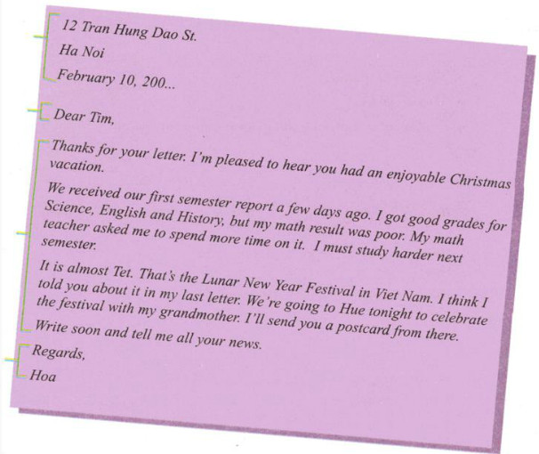

Task 2. Now help Lan write a letter to her pen pal Donna in San Francisco. Use the information in the box.

Mother’s Day
second semester report / last month
good grades / Geography / Physics / Math
teacher / tell / improve English / History
in a few weeks / Mid-Autumn Festival / moon festival
Ha Long Bay / aunt and uncle / bus / this afternoon
send you / postcard

SUGGESTED ANSWER
124 Hai Ba Trung St.
Ha Noi
June 5, 200...
Dear Donna,
Thanks for your letter. I'm happy to hear that you had a nice Mother’s Day.
I received my second-semester report last month. I got good grades for Geography, Physics, and Math, but my History and English results were not very good. My former teacher told me that I should improve English and History. I am spending more time on them this summer. And I hope I'll be better at the two subjects next year.
The Mid-Autumn Festival will come in a few weeks. That’s the Moon Festival in Viet Nam. I'm going to Ha Long Bay with my aunt and uncle by bus this afternoon. I'll send you a postcard from there.
Write to me as soon as possible. I'm looking forward to hearing from you.
Fondest wishes,
Lan

